Handout 5: Spaghetti Diagram¹⁰⁵
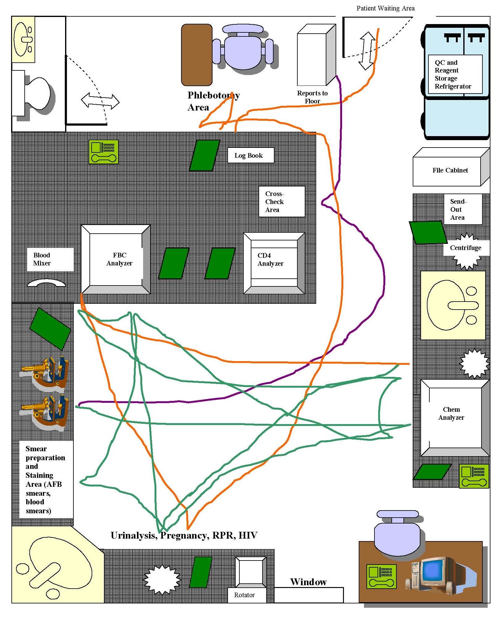
Window

